Sabbath devotion Lent 2020
Dusting off/on the faith

We are met in the presence of God.
And we do not meet alone.
With the angels in highest heaven,
we gather to worship the Lord.
With the hungry and thirsty, the stranger, the naked, the sick, the imprisoned,
we gather to worship the Lord.
By poor widows and those in want,
God’s holy name is praised.
With incense and updrafts,
God’s holy name is praised.
In tents, tabernacles, towers, and temples,
God’s holy name is praised.
And here in our hearts and togetherness,
God’s holy name is praised.
We are met in the presence of God,
And we do not meet alone.
Let us pray.
Generous God, you give us our voices, no two the same, no finer instruments with which to praise you.
For this we thank you, Lord.
Help us to be the stewards you created us to be, for the sake of the world, for the sake of everyone in the world. You give our earth everything that everyone needs to live on.
For this we thank you, Lord.
And in your Church you have gathered us: in your community of
common folk and complainers,
prophets and puzzled people,
you have made a place for us.
For this we thank you, Lord.
So let what we say and do here be real for us and honest to you, and prepare us for the life of the world in which you also are praised.
Amen.

Adapted from Evening Liturgy E in A Wee Worship Book, by Wild Goose Worship Group, c. 1999, GIA Publications.
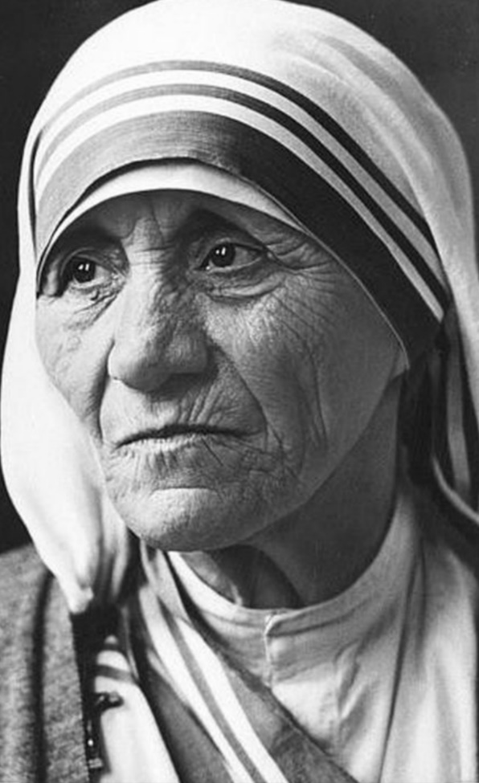
The holy Gospel according to St. Luke 20^{:45} - 21^{:4}
In the last week of his life, Jesus found it important enough to say this…
⁴⁵In the hearing of all the people
Jesus said to the disciples,
⁴⁶‘Beware of the scribes,
who like to walk around in long robes,
and love to be greeted with respect in the market-places,
and to have the best seats in the synagogues
and places of honor at banquets.
⁴⁷They devour widows’ houses
and for the sake of appearance say long prayers.
They will receive the greater
condemnation.’
¹Jesus looked up and saw rich people putting their gifts into the treasury;
²he also saw a poor widow put in two small copper coins.
³He said, ‘Truly I tell you,
this poor widow has put in more than all of them;
⁴for all of them have contributed
out of their abundance,
but she
out of her poverty
has put in
all she had to live on.’
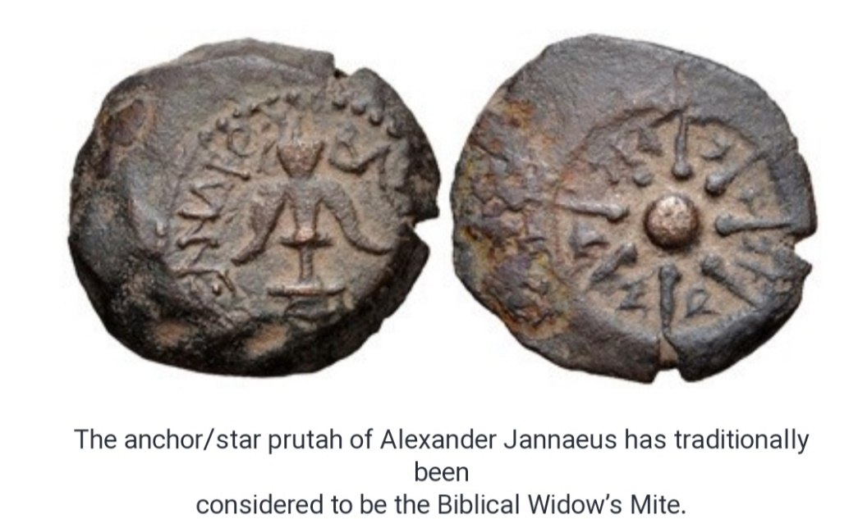

Devotion by Pastor Tom - Dust mites (what do they live on?); Our daily bread (what we live on)
I hope that these words proceed from, and are worthy of, the mouth of God…
“EXFOLIATE” was a foreign word to me. I do not remember being familiar with that word until it became common verbiage in our home a few years ago. And it just so happens, it actually does come from a foreign language!
“ex-” is Latin for “out, from” and
“folium” is Latin for “leaf”
Deciduous trees ‘exfoliate.’ And here I always thought that the leaves just fell off.
Trees are not the subject matter of this word in our home, however. People are. And the “leaves” that fall off, with a little help I dare say, is old skin.
I am told that this is a good thing. I can be old school about some things, so unless it is a bad sun burn, my skin can just fall off by itself, like I like to think the leaves do off of a tree.
Well, all of those human “leaves” have to go somewhere, (and just as in nature, they nurture), so too, our skin “leaves” provide nutrition in our homes.
As bamboo is to a panda, as nectar is to a hummingbird, as eucalyptus is to a koala, so our dead skin is to dust mites.
That’s right, dust mites live on the old… “you.”
You cannot see dust mites, but they are there.
But if you have the right “equipment,” you can see them.
Is that how it is with the poor widows of this world? They are there, but we can come to not see them. Have you ever felt unseen like a poor widow?
Can the same thing even happen with Jesus?
He is there, but we can come to not see him.
Yet Jesus offers the right “equipment” to see him (and the poor widows of this world), in Matthew 25. ‘Whenever you did it to one of the least of these, you did it to me.’
Take heart. Jesus sees the poor widow. Jesus sees her giving her all for God. Maybe just like Jesus saw Mother Teresa giving her all to God.
Mother Teresa caring for everyone she could.
Mother Teresa making the world see everyone she could.
Mother Teresa wondering sometimes if there was a God to see everyone she could.
Mother Teresa giving her all, because whether there was a God or not, all needed what she offered: to be seen like Jesus….
Jesus sees the poor widow. Jesus sees Mother Teresa. And Jesus see you.
Dust mites live on the old, you. The scribes lived on the old, too. We live on something new.
The first Sunday of Lent, Jesus told the devil that we do not live by bread alone, but by every word that proceeds from the mouth of God. We live. Amen

Another variation of our Lenten creed
I believe in God:
the Father almighty, who created us out of the dust of the ground.
I believe in Jesus Christ, God’s only Son, our Lord.
He became dust, that we might be one with the One who created dust, even that of the stars.
Where his kingdom was not received, he implored his disciples to shake that dust off of their feet. He walked dusty roads; he washed dusty feet. He loved widows who had little more than dust to their name.
And then, crucified, he returned to the dust.
But if the huge stone at the tomb could not go unmoved by Life, how could the deathly dust that settled on him not rise up.
I believe in the Holy Spirit,
who stirs the dust and gives it flight,
who helps those of the dust to believe in Jesus,
+ carries those of the dust in God’s way. Amen

Let us pray for what we live on; for our daily bread. In the Small Catechism Martin Luther wrote,
“God gives daily bread without our prayer, even to all evil people,
but we ask in this prayer that God cause us to recognize what our daily bread is
and to receive it with thanksgiving.”
Luther goes on to say that daily bread is
“Everything included in the necessities and nourishment for our bodies, such as
- food and drink,
- clothing and shoes,
- house, farm, fields, and livestock,
- money and property,
- an upright spouse, upright children, upright members of the household, upright and faithful rulers,
- good government, good weather,
- peace, and health, decency and honor,
- good friends, faithful neighbors, and the like.”
And so we pray for this daily bread:
Our Father, who art in heaven, hallowed be thy name. Thy kingdom come, thy will be done, on earth as it is in heaven.
GIVE US THIS DAY OUR DAILY BREAD.
And forgive us our trespasses as we forgive those who trespass against us. And lead us not into temptation, but deliver us from evil.
For thine is the kingdom, and the power, and the glory, forever and ever. Amen

We close this devotional with a song from Shawn Smith’s RESTORATION CD that sings the song of poor widows and those of such faith.
“It’s not much”
And this time we’ve been blessed to receive
We humbly offer it to you (2x)
It’s not much, but it’s all that we have
We humbly offer it to you (2x)
And these hands, we’ve been blessed to receive
We humbly offer them to you (2x)
It’s not much, but it’s all that we have
We humbly offer it to you (2x)
And this song, we’ve been blessed to receive
We humbly offer it to you (2x)
It’s not much, but it’s all that we have
We humbly offer it to you (2x)
And these gifts, we’ve been blessed to receive
We humbly offer them to you (2x)
It’s not much, but it’s all that we have
We humbly offer it to you…
…Lord, may we humbly present our gifts to you.

